Low Power Wide Area Networks: An Overview

Usman Raza, Parag Kulkarni, and Mahesh Sooriyabandara, Senior Member, IEEE Review by Tuğrul Yatağan and Sinan Atan

*Abstract*—Low power wide area (LPWA) networks offer affordable connectivity to the low-power devices distributed over very large geographical areas. LPWA technologies complement and sometimes supersede the conventional cellular and short range wireless technologies. LPWA technologies exploit to offer wide-area coverage to low-power devices at the expense of low data rates. Researchers survey several emerging LPWA technologies (e.g., LoRa, Sigfox) and the standardization activities carried out by different standards development organizations.

*Index Terms*—Internet of Things, IoT, low power wide area, LPWA, LPWAN.

# INTRODUCTION

T

he Internet of Things help us in overcoming the top global challenges resulting from population explosion, energy crisis and resource depletion. Number of connected M2M devices and consumer electronics will surpass the number of human subscribers using mobile phones, personal computers, laptops and tablets by 2020 [2]. By 2024, the overall IoT industry is expected to generate a revenue of 4.3 trillion dollars [3]

LPWA technologies offer unique sets of features including wide-area connectivity for low power and low data rate devices, not provided by legacy wireless technologies. LPWA networks are unique because they make different tradeoffs than the traditional technologies prevalent in IoT landscape such as short-range wireless networks. The legacy non-cellular wireless technologies are not ideal to connect low power devices distributed over large geographical areas. The range of these technologies is limited to a few hundred meters at best. The range of these technologies is extended using a dense deployment of devices.

With a phenomenal range of a few to tens of kilometers [4] and battery life of ten years and beyond, LPWA technologies are promising for the Internet of low-power, low-cost, and low throughput things. It is worth clarifying that LPWA technologies achieve long range and low power operation at the expense of low data rate and higher latency. Therefore, it is clear that LPWA technologies are not meant to address each and every IoT use case. Specifically, LPWA technologies are considered for those use cases that are delay tolerant, do not need high data rates, and typically require low power consumption and low cost.

At this moment, there are several competing LPWA technologies, each employing various techniques to achieve long range, low power operation, and high scalability.

# DESIGN GOALS AND TECHNIQUES

LPWA technologies share some of the design goals with other wireless technologies. The key objective of LPWA technologies is, however, to achieve a long range with low power consumption.

## Long Range

Quantitatively, a +20 dB gain over legacy cellular systems is targeted. This allows the end-devices to connect to the base stations at a distance ranging from a few to tens of kilometers

### *Sub-1GH Band*

### Most of the LPWA technologies use Sub-GHz band, which offers robust and reliable communication at low power budgets. Lower frequency signals experience less attenuation and multipath fading

### *Modulation*

The physical layer compromises on high data rate and slows downs the modulation rate to put more energy in each transmitted symbol. Two classes of modulation techniques namely narrowband and spread spectrum techniques have been adopted by different LPWA technologies. Narrowband modulation techniques provide a high link budget by encoding the signal in low bandwidth. Spread spectrum techniques spread a narrowband signal over a wider frequency band but with the same power density.

## Low Power

A battery lifetime of 10 years or more with AA or coin cell batteries is desirable to bring the maintenance cost down.

### *Topology*

Mesh topology has been extensively used to extend the coverage of short range wireless networks, their high deployment cost is a major disadvantage. LPWA technologies overcomes these limitations by connecting end devices directly to base stations, obviating the need for the dense and expensive deployments. As opposed to the mesh topology, the devices need not to waste precious energy in busy-listening to other devices.

### *Duty Cycle*

### Radio duty cycling allows LPWA end devices to turn off their transceivers, when not required. Only when the data is to be transmitted or received, the transceiver is turned on.

Regional regulations on sharing spectrum may limit the time a single transmitter can occupy to assure its coexistence with other devices sharing the same channel.

### *Simple Medium Access*

Most-widely used Medium Access Control protocols for cellular networks or short range wireless networks are too complex for LPWA technologies. Tight synchronization needed by these schemes is difficult to be met by ultra-low-cost end devices having low quality cheap oscillators. LPWA technologies cannot usually afford this excessive signaling overhead of CMSA/CA. Moost of the LPWA technologies uses ALOHA. Simplicity of ALOHA is thought to keep design of transceiver simple and low cost.

### *Offloading Complexity From End Devices*

LPWA technologies simplify the design of end devices by offloading complex tasks to the base stations or to the backend system. This allows end devices to send data using any available channel or orthogonal signal and still reach the base station without need for expensive signaling to initiate communication.

## Low Cost

LPWA technologies adopt several ways to reduce the capital expenses (CAPEX) and operating expenses (OPEX) for both the end-users and network operators.

### *Reduction in Hardware Complexity*

### LPWA transceivers need to process less complex waveforms which enables them to reduce transceiver footprint.

### *Minimum Infrastructure*

### A single LPWA base station connects tens of thousands of end devices distributed over several kilometers, significantly reducing the costs for network operators.

### *Using License-Free or Owned Licensed Bands*

### Most LPWA technologies considered deployment in the license-exempt bands including the industrial, scientific and medical band which enables low cost deployment and short time to market.

## Scalibility

LPWA technologies support massive number of devices sending low traffic volumes.

### *Diversity Techniques*

*E*fficient exploitation of diversity in channel, time, space, and hardware is vital. Much of this is achieved by more powerful components in networks such as base stations and backend systems.

### *Densification*

LPWA networks, like traditional cellular networks, will resort to dense deployments of base stations.

# PROPRIETARY TECHNOLOGIES

Researchers highlight and compare emerging proprietary

technologies and their technical aspects summarized in Table 1.

## Sigfox

Sigfox is partnership with other network operators offers an end-to-end LPWA connectivity solution based on its patented technologies. They deploy the proprietary base stations. The end devices connect to these base stations using Binary Phase Shift Keying modulation in an ultra-narrow sub-GHZ ISM band resulting in high receiver sensitivity, ultra-low power consumption in expense of maximum throughput of only 100 bps. The number and size of messages over the uplink are limited to 140 12-byte messages per day and 4 8-bytes per day over the downlink. A single message from an end device can be transmitted multiple times over different frequency channels to increase reliability.

## LoRa

LoRa is a physical layer technology that modulates the signals in sub-GHz ISM band using a proprietary spread spectrum technique. The resulting signal has noise like properties ehich enables resilience to interference and noise. LORa supports multiple spreading factors to decide the tradeoff between range and data rate. The data rate ranges from 300 bps to 37.5 kbps depending on spreading factor.

LoRaWAN is an open standard defining architecture and layers above the LoRa physical layer designed by LoRa Allience.

## INGENU

INGENU unlike most other technologies does not rely on better propagation properties of sub-GHz band. Instead it operates in 2.4 GHz ISM band and leverages more relaxed regulations. INGENU uses a patented physical access scheme named as Random Phase Multiple Access Direct Sequence Spread Spectrum which it employs for uplink communication only.

# STANDARDS

Lorem ipsum dolor sit amet, consectetur adipiscing elit. Ut eget nisl enim. Proin tempus pellentesque mauris, a pharetra ligula interdum sit amet. Duis ultrices nisl sed accumsan aliquet.

## IEEE

Lorem ipsum dolor sit amet, consectetur adipiscing elit. Ut t nisl enim. Proin tempus pellentesque mauris, a pharetra ligula interdum sit amet.

### *IEEE 802.15.4k (Low Energy, Critical Infrastructure Monitoring Networks)*

Lorem ipsum dolor sit amet, consectetur adipiscing elit. Ut eget nisl enim. Proin tempus pellentesque mauris,

### *IEEE 802.11 (Wireless Local Area Networks)*

Lorem ipsum dolor sit amet, consectetur adipiscing elit. Ut eget nisl enim. Proin tempus pellentesque mauris,

### *IEEE 802.15.4g (Low-Data-Rate, Wireless, Smart Metering Utility Networks*

Lorem ipsum dolor sit amet, consectetur adipiscing elit. Ut eget nisl enim. Proin tempus pellentesque mauris

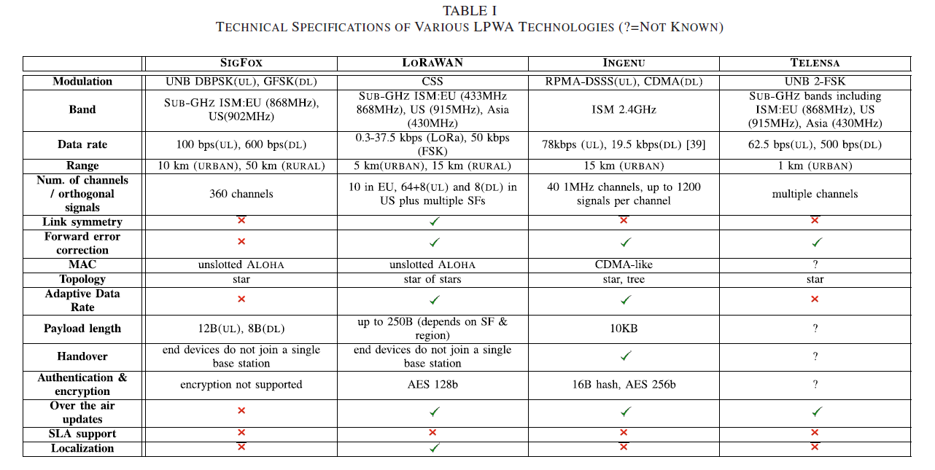

## ETSI

Lorem ipsum dolor sit amet, consectetur adipiscing elit. Ut eget nisl enim. Proin tempus pellentesque mauris, a pharetra ligula interdum sit amet.

## 3GPP

Lorem ipsum dolor sit amet, consectetur adipiscing elit. Ut eget nisl enim. Proin tempus pellentesque mauris, a pharetra ligula interdum sit amet.

## LoRa Allience

Lorem ipsum dolor sit amet, consectetur adipiscing elit. Ut eget nisl enim. Proin tempus pellentesque mauris, a pharetra ligula interdum sit amet.

## WEIGHTLESS-SIG

Lorem ipsum dolor sit amet, consectetur adipiscing elit. Ut eget nisl enim. Proin tempus pellentesque mauris, a pharetra ligula interdum sit amet.

# CHALLENGES AND OPEN RESEARCH DIRECTIONS

Lorem ipsum dolor sit amet, consectetur adipiscing elit. Ut t nisl enim. Proin tempus pellentesque mauris, a pharetra ligula interdum sit amet.

## Scaling Networks to Massive Number of Devices

Lorem ipsum dolor sit amet, consectetur adipiscing elit. Ut t nisl enim. Proin tempus pellentesque mauris, a pharetra ligula interdum sit amet.

## Interference Control and Mitigation

Lorem ipsum dolor sit amet, consectetur adipiscing elit. Ut t nisl enim. Proin tempus pellentesque mauris, a pharetra ligula interdum sit amet.

## Interoperability Between Different LPWA Technologies

Lorem ipsum dolor sit amet, consectetur adipiscing elit. Ut t nisl enim. Proin tempus pellentesque mauris, a pharetra ligula interdum sit amet.

## Localization

Lorem ipsum dolor sit amet, consectetur adipiscing elit. Ut t nisl enim. Proin tempus pellentesque mauris, a pharetra ligula interdum sit amet.

# BUSINESS CONSIDERATIONS

Lorem ipsum dolor sit amet, consectetur adipiscing elit. Ut eget nisl enim. Proin tempus pellentesque mauris, a pharetra ligula interdum sit amet. Duis ultrices nisl sed accumsan aliquet.

# CONCLUSION

Lorem ipsum dolor sit amet, consectetur adipiscing elit. Ut eget nisl enim. Proin tempus pellentesque mauris, a pharetra ligula interdum sit amet. Duis ultrices nisl sed accumsan aliquet.

References

1. U. Raza, P. Kulkarni and M. Sooriyabandara, "Low Power Wide Area Networks: An Overview", IEEE Communications Surveys & Tutorials, vol. 19, no. 2, pp. 855-873, second quarter 2017
2. “Cellular networks for massive IoT: Enabling low power wide area applications,” Ericsson, Stockholm, Sweden, Tech. Rep. UEN 284 23-3278, Jan. 2016. [Online]. Available: <https://www.ericsson.com/res/docs/whitepapers/wp_iot.pdf>
3. E. Berthelsen and J. Morrish, “Forecasting the Internet of thing revenue opportunity,” Machina Res., London, U.K., Tech. Rep.,

Apr. 2015. [Online]. Available: https://machinaresearch.com/

report/forecasting-the-internet-of-things-revenue-opportunity/

1. J. Petajajarvi, K. Mikhaylov, A. Roivainen, T. Hanninen, and

M. Pettissalo, “On the coverage of LPWANs: Range evaluation and

channel attenuation model for LoRa technology,” in Proc. 14th Int.Conf.

ITS Telecommun. (ITST), Copenhagen, Denmark, Dec. 2015, pp. 55–59.

**Tuğrul Yatağan** received the Bachelor of

Science (B.Sc.) degree in computer engineering from Istanbul Technical University, Istanbul, Turkey. He is embedded software engineer at Maxim Integrated Products. He worked at Airties Wireless Networks as a software engineer. He is currently studying Master of Science (M.Sc.) degree in computer engineering in Istanbul Technical University. His research areas are computer communications and LoRa.



**Sinan Atan** received the Bachelor of

Science (B.Sc.) degree in electronics and communication engineering and Master of Science (M.Sc.) degree in telecommunications engineering from Istanbul Technical University, Istanbul, Turkey. He is working at Ericsson as solution architect.